

MOBILE ELECTRONIC DOCUMENTATION (MED)

USER MANUAL

Documentation Patch: TIU*1.0*311
Server Patch: TIU*1.0*257
Client Software: Version 2.3.311.6

June 2017

Department of Veterans Affairs (VA)
Office of Information & Technology (OIT)
Product Development (PD)

This page intentionally left blank for double-sided printing.

Revision History

Date | Revision | Description | Author
06/02/2017 | 2.9 | Update for Patch TIU*1*311  Two-Factor Authentication (2FA)  Updated all MED document file references to the following:  - TIU_1_311_MED_IG.doc/pdf  - TIU_MED_TM.doc/pdf  - TIU_MED_UM.doc/pdf | Project Manager – R. Ades  Tech Writer – D. Michael; S. Crichlow/Honey Chipman
09/21/2011 | 2.8 | Tech review and edit updates based on review/feedback from Richard Sipe review:  - Updated all MED document file references to the following:  - TIU_1_262_MED_IG.doc/pdf  - TIU_1_262_MED_TM.doc/pdf  - TIU_1_262_MED_UM.doc/pdf  - Updated all footers to reference MED GUI Software Version 2.3 and documentation Patch TIU*1.0*262. | Project Manager—Tim Landy  Tech Writer—Thom Blom
09/15/2011 | 2.7 | Tech review and edit updates based on review/feedback from Richard Sipe review:  - Updated the following highlighted text in the second paragraph in Chapter 2:  "After starting MED, in order to access the MED menu toolbars, you must first retrieve a patient, then select a patient from the Patient Selection opening dialogue."  - Updated the second Note in Chapter 2, on Page 3. Added the following text:  "While connected to the VA network/VistA, if you do not supply the appropriate signon credentials (i.e., VA Access and Verify codes) you can access MED but cannot retrieve patients and summaries. You must sign into MED using the appropriate signon credentials before being given access to retrieve patient information from VistA."  - Updated the Cautionary Note in Section 3.1 as follows:  "CAUTION: If the patient name on the list is not a manually entered patient, when MED is started, any notes that have been imported over 7 days prior are deleted. Then, any patients that are over 7 days old and do not have any pending or imported notes are deleted as well."  And in Section 10.3.1.  - Updated notes in Step 2 in Section 3.2. Changed "need" to "needed."  - Updated entering date of Birth information in Step 2d under the "Manually Enter a Patient" bullet in Section 3.2, Retrieving Patient Records Procedures."  - Updated the "Summary Tab Overview" section. Changed "which includes:" to "which may include:".  - Added the following sentence to blank pages added so all chapter/document ends on an even page for double-sided printing:  "This page intentionally left blank for double-sided printing." | Project Manager—Tim Landy  Tech Writer—Thom Blom
09/05/2011 | 2.6 | Tech review and edit updates based on review/feedback from MED Core team:  - Added Step 3 to Section 3.2, "Retrieving Patient Records Procedures" informing users to press the Close button to return to MED after selecting patients, as per J. Pasternock.  - Updated introductory paragraph and Step 1 procedures in Section 7.3, "Create and Assign a Health Summary to MED," as per J. Pasternock.  - Added all missing errors from the MED Technical Manual to Chapter 12, "Appendix B—Troubleshooting."  Includes updates to the "Write Access Error" error description and resolution to state users must be given Full Control access permission to the MED directory (i.e., Read, Write, Modify, and Execute), as per J. Pasternock, R. Hines, and R. Sipe.  - Added a Note informing users to enter a Remedy ticket if the resolutions listed in the errors described in Chapter 12, "Appendix B—Troubleshooting," do not resolve the issue.  - Added the "CPRS CHART – Library Not Registered Error" error message to Chapter 12, "Appendix B—Troubleshooting," as per feedback from R Hines.  - Updated index entries for error messages in Chapter 12, "Appendix B—Troubleshooting." | Project Manager—Tim Landy  Tech Writer—Thom Blom
08/11/2011 | 2.5 | Tech review and edit updates based on review/feedback from MED Core team:  - Removed patch compliance dates from the "How to Use this Manual", as per Chuck Schofer. | Project Manager—Tim Landy  Tech Writer—Thom Blom
08/10/2011 | 2.4 | Tech review and edit updates based on review/feedback from MED Core team:  - Updated "Assumptions About the Reader" section to remove reference to the M programming language, as per Robert Graziani (SQA) review.  - Reordered and added content and updated intro paragraph in the "Starting MED" section, as per Richard Sipe review.  - Added definitions for Retrieving Patient Records vs. Selecting Patient Records in MED in the "Retrieving Patient Records Overview" and "Glossary" sections, as per Richard Sipe review.  - Updated procedures in Step 1 in the "Retrieving Patient Records Procedures" section.  - Added commentary to "Select a Patient" button in the "Retrieving Patient Records Procedures" section, as per Richard Sipe review.  - Added a Note regarding entering "Last Name,First Name" and spaces after comma in the "Manually Enter a Patient" bullet in the "Retrieving Patient Records Procedures" section, as per Richard Sipe review.  - Updated the "Selecting a Patient" section as per Richard Sipe review.  - Removed instructions for disabling retrieval of Health Summaries in the "Summary Tab Procedures" section, as per Richard Sipe review.  - Added Cautionary Note to Step 3 in the "Retrieve Health Summaries from VistA" section.  - Updated the Notes in the "Creating Templates and Directory Access" section.  - Updated figures in Step 6 in the "New Progress Notes" section, as per Richard Sipe review.  - Added a Note to the Description field for the TIU MED MANUAL PATIENT security key in Table 1, as per Richard Sipe review.  - Updated patient names in Table 2 through Table 5, as per Richard Sipe review.  - Updated the image and directory path for the MED database reference in the "MED Database Open Error" section.  - Added compact database messages to the new "MED Database Compact Messages" section, as per Seth Thompson email.  - Removed author references, other than Project Manager and Tech Writer, from "Revision History" section, as per Product Support review.  - Updated the Note contact info in Step 2b in the "Retrieving Patient Records Procedures" section, as per Product Support review.  - Removed "Product Support (PS)" from the "Intended Audience" section, as per Product Support review. | Project Manager—Tim Landy  Tech Writer—Thom Blom
07/27/2011 | 2.3 | Tech review and edit updates based on review/feedback from Product Support team:  - Added all Mobile Electronic Device (MED) VistA patch references and Graphical User Interface (GUI) client software version to the Title page.  - Added the "Orientation" section in accordance with national documentation standards. Moved topics from the "Introduction" section into this new section.  - Added a note regarding Access/Verify code prompt in the "Retrieving Patient Records Procedures" section.  - Deleted the procedures for deleting a manually entered patient from the "Delete Manually Entered Patients (Duplicates)" section. This information is in the MED Technical Manual.  - Added a Cautionary Note warning users about disabling Health Summaries in the "Summary Tab Procedures" section.  - Added the "Create and Assign a Health Summary to MED" section.  - Updated content in the "Creating Templates and Directory Access" section. Removed procedures for setting up network directory, since that information is already in the MED Technical Manual.  - Deleted and moved the procedures for deleting a template from the "Deleting Templates" section. This information was moved to the MED Technical Manual.  - Updated the content in the "Editing Existing Notes" section.  - Updated the content in the "Finding Text in Notes" section.  - Updated the Cautionary Note in the "Saving Notes" section. | Project Manager—Tim Landy  Tech Writer—Thom Blom
07/14/2011 | 2.2 | Tech review and edit updates:  - Updated the "Saving Notes" section to say "Select a new patient" rather than "Start a new patient," as per J. Pasternock review.  - Added reference to procedures for selecting a new patient and added text to the Cautionary Note regarding shutting down the laptop before properly closing MED, as per Joy Pasternock review. | Project Manager—Tim Landy  Tech Writer—Thom Blom
07/12/2011 | 2.1 | Tech review and edit updates:  - Updated the "Date Sensitivity" section in the "Import Criteria for Progress Notes" topic, as per Jeanie Scott review.  - Remedy Tickets #487293, 50587, and 502588: Updated content regarding properly saving a MED note in the "Saving Notes" section, as per Jeanie Scott review.  Added the "Delete Manually Entered Patients" section regarding removing manually entered patients from the MED database, as per Jeanie Scott review.  - Added the "Write Scratch Pad Text," "Find Scratch Pad Text," and "Delete Scratch Pad Text" (Remedy Ticket #487029) topics to the "Scratch Pad Tab" section, as per Jeanie Scott review.  - Remedy Ticket #487861: Updated the "Creating Templates and Directory Access" and "Deleting Templates" sections with screen captures, as per Jeanie Scott review. | Project Manager—Tim Landy  Tech Writer—Thom Blom
06/23/2011 | 2.0 | Tech review and updates:  - Renamed document to remove patch reference ID.  - Reformatted document to follow current national documentation standards and style guides.  - Added alternate text to all images for Section 508 compliance.  - Updated the "Introduction" section to be consistent across the MED documentation set.  - Updated Index entries.  - Remedy Ticket #485510: Added the "Date Sensitivity" section in the "Import Criteria for Progress Notes" topic.  - Remedy Tickets #465060 and #487293: Added the "Saving Notes" section with a Cautionary Note of known software anomaly.  - Remedy Ticket #476482: Corrected Step 4 in "New Progress Notes" section.  - Remedy Ticket #485507: Added the "Creating Templates and Directory Access" and "Deleting Templates" sections. These sections will need additional content updates: detailed procedures, examples, and GUI screen captures.  - Made grammar, punctuation, and spelling updates as needed. | Project Manager—Tim Landy  Tech Writer—Thom Blom
06/03/2010 | 1.0 | Initial document. | MED Development Team

Contents

Revision History iii
Figures and Tables xiv
Orientation xvi
1 Introduction 1
2 Starting MED 3
3 Retrieving Patient Records 5
3.1 Retrieving Patient Records Overview 5
3.2 Retrieving Patient Records Procedures 5
3.3 Delete Manually Entered Patients (Duplicates) 10
4 Selecting a Patient 11
5 Patient Information Available from Any Tab 13
6 Printing from Within MED 15
6.1 Printing Health Summaries and Notes Overview 15
6.2 Printing Health Summaries and Notes Procedures 15
7 Summary Tab 17
7.1 Summary Tab Overview 17
7.2 Summary Tab Procedures 19
7.2.1 Retrieve Health Summaries from VistA 19
7.2.2 Find Health Summary Text 20
7.3 Create and Assign a Health Summary to MED 22
8 Scratch Pad Tab 23
8.1 Scratch Pad Tab Overview 23
8.2 Scratch Pad Procedures 23
8.2.1 Write Scratch Pad Text 23
8.2.2 Find Scratch Pad Text 24
8.2.3 Delete Scratch Pad Text 25
8.3 Creating Templates and Directory Access 26
8.4 Deleting Templates 26
9 Notes Tab 27
9.1 Icons on the Notes Tab 27
9.2 Viewing Notes 28
9.3 Creating and Editing Notes 29
9.4 Editing Existing Notes 31
9.5 Saving Notes 31
9.6 Finding Text in Notes 32
10 Importing MED Notes into CPRS 35
10.1 Existing Progress Notes 35
10.2 New Progress Notes 37
10.3 Import Criteria for Progress Notes 39
10.3.1 Date Sensitivity 39
10.3.2 Security Keys 40
10.3.3 Import Examples 41
11 Appendix A—Keyboard Shortcuts for Common MED Commands 43
11.1 Navigation Commands 43
11.2 File Menu Commands 43
11.3 Edit Menu Commands 44
11.4 View Menu Commands 44
11.5 Tools Menu Commands 44
11.6 Action Menu Commands 44
11.7 Help Menu Commands 45
12 Appendix B—Troubleshooting 47
12.1 Patch TIU*1*257 is Not Current in VistA Error 47
12.2 MED Missing Remote Procedure Calls (RPCs) in VistA Error 48
12.3 Invalid Pointer Operation Error 48
12.4 Application Context Error 49
12.5 Write Access Error 50
12.6 CPRS CHART – Library Not Registered Error 50
12.7 MED Database Open Error 51
12.8 MED Database Compact Messages 52
12.9 Network Connection Error 53
12.10 RPC Broker Error 54
12.11 CPRS Error 55
12.12 Invalid Date Error 56
12.13 Missing Required Data Fields Error 56
13 Appendix C—Mobile Electronic Documentation (MED) Frequently Asked Questions
(FAQ) 59
Glossary 61
Index 63

This page intentionally left blank for double-sided printing.

Figures and Tables

Figures

Figure 1. MED—Desktop shortcut icon 3
Figure 2. MED—Patient Selection dialogue 3
Figure 3. MED—Retrieve Patient(s) dialogue 6
Figure 4. MED—Retrieve Patient(s): Personal Lists dialogue 7
Figure 5. MED—Retrieve Patient(s): Select Patient dialogue 8
Figure 6. MED—Retrieve Patient(s): Manually enter a Patient dialogue 10
Figure 7. MED—Patient Selection dialogue 11
Figure 8. MED—Patient information 13
Figure 9. MED Menus—File and Print options (partial capture) 15
Figure 10. MED—Print Documents dialogue: Sample list of notes that can be printed 16
Figure 11. MED—Print dialogue 16
Figure 12. MED—Health Summary tab dialogue 18
Figure 13. MED Menus—Tools and Settings options (partial capture) 19
Figure 14. MED Users & Settings dialogue—Data & Files 20
Figure 15. MED—Find dialogue 20
Figure 16. MED—Health Summary tab: Find dialogue 21
Figure 17. MED—Scratch Pad tab dialogue 23
Figure 18. MED—Find dialogue 24
Figure 19. MED—Scratch Pad tab: Find dialogue 25
Figure 20. MED—Notes tab 28
Figure 21. MED—Create a Note dialogue: Sample list of note templates that can be created 29
Figure 22. MED—Home Based Primary Care (HBPC) template: CO-HBPC Note (D) 30
Figure 23. MED—Close button 31
Figure 24. MED—Find dialogue 32
Figure 25. MED—Notes tab: Find dialogue 33
Figure 26. CPRS—Patient Selection dialogue 35
Figure 27. CPRS—Select Note to Import dialogue 36
Figure 28. CPRS—Patient Selection dialogue 37
Figure 29. CPRS—Progress Note Properties dialogue 38
Figure 30. MED—Select Note to Import dialogue (sample 1 of 2) 38
Figure 31. MED—Select Note to Import dialogue (sample 2 of 2) 39
Figure 32. MED Error—Patch TIU*1*257 is not current in VistA 47
Figure 33. MED Error—Missing RPCs 48
Figure 34. MED Error—Invalid pointer operation 48
Figure 35. MED Error—Application context 49
Figure 36. MED Error—Write access permissions error 50
Figure 37. MED Error—CPRS CHART – Library Not Registered Error 50
Figure 38. MED Error—Database is not installed correctly 51
Figure 39. MED Warning—Database closing 52
Figure 40. MED Information Message—Database Compacted 52
Figure 41. MED Error—Network Connection: Blank Retrieve Patient(s) dialogue (1 of 2) 53
Figure 42. MED Error—Network Connection: Blank Retrieve Patient(s) dialogue (2 of 2) 54
Figure 43. Errors—RPC Broker Error: Patient list retrieval error 54
Figure 44. Errors—CPRS - Patient Chart Error: Importing notes error message 55
Figure 45. MED Error—Invalid date 56
Figure 46. MED Error—Missing required data fields and Section 508 compliance: Active Caption
Color 56

Tables

Table 1. MED—Security keys for validating patient identification for manually entered MED
patients 40
Table 2. Import Example—TIU MED MANUAL PATIENT security key 41
Table 3. Import Example—TIU MED MANUAL OVERRIDE security key: Different names 41
Table 4. Import Example—TIU MED MANUAL OVERRIDE security key: Different DOB 41
Table 5. Import Example—Unable to import due to different SSNs 42
Table 6. MED Navigation commands—Keyboard shortcuts 43
Table 7. MED File menu commands—Keyboard shortcuts 43
Table 8. MED Edit menu commands—Keyboard shortcuts 44
Table 9. MED View menu commands—Keyboard shortcuts 44
Table 10. MED Tools menu commands—Keyboard shortcuts 44
Table 11. MED Action menu commands—Keyboard shortcuts 44
Table 12. MED Help menu commands—Keyboard shortcuts 45

Orientation

How to Use this Manual

The Mobile Electronic Documentation (MED) application consists of both a Veterans Health Information Systems and Technology Architecture (VistA) M Server component and a Microsoft® Windows laptop/client workstation Graphical User Interface (GUI) component:
- Original VistA M Server Patch: TIU*1.0*244 (released date: 06/03/2010).
- Updated VistA M Server Patch: TIU*1.0*257 (released date: 01/21/2011).
- Documentation-only VistA M Server Patch TIU*1.0*262.
- Current Laptop/Client Workstation software: MED.exe Version 2.3.311.6.

This manual is organized to help users understand the basic layout of the MED software and provide users with information about the specific tasks performed. It includes sections on the following topics:
- Starting MED—How to start the application
- Retrieving Patient Records—Supplying patient credentials
- Selecting a Patient—How to select a patient
- Patient Information Available from Any Tab—An explanation of the features that are available from each MED tab
- Printing from Within MED
- Summary Tab
- Scratch Pad Tab
- Notes Tab
- Importing MED Notes into CPRS
- Appendix A—Keyboard Shortcuts for Common MED Commands
- Appendix B—Troubleshooting
- Appendix C—Mobile Electronic Documentation (MED) Frequently Asked Questions (FAQ)

MED works in tandem with CPRS; however, this manual does not attempt to fully document how to create templates or describe other functions of CPRS.

 | REF: For installation instructions; lists of routines, files, and options; additional technical information; and user information on CPRS, see the CPRS documentation on the VA Document Library (VDL) at the following link:  http://www.va.gov/vdl/application.asp?appid=61

Intended Audience

The intended audience of this manual is all key stakeholders. The stakeholders include the following:
- Information Resource Management (IRM)
- Clinical Application Coordinators (CAC)
- Home Based Primary Care (HBPC) end-users
- Product Support (PS).

Legal Requirements

There are no special legal requirements involved in the use of MED software.

Disclaimers

This manual provides an overall explanation of how to configure the MED software; however, no attempt is made to explain how the overall VistA programming system is integrated and maintained. Such methods and procedures are documented elsewhere. We suggest you look at the various VA Web sites on the Internet and VA Intranet for a general orientation to VistA. For example, visit the Office of Information & Technology (OIT) VistA Development VA Intranet Web site:
http://vaww.vista.med.va.gov/

 | DISCLAIMER: The appearance of any external hyperlink references in this manual does not constitute endorsement by the Department of Veterans Affairs (VA) of this Website or the information, products, or services contained therein. The VA does not exercise any editorial control over the information you may find at these locations. Such links are provided and are consistent with the stated purpose of this VA Intranet Service.

Documentation Conventions

This manual uses several methods to highlight different aspects of the material:
- Various symbols are used throughout the documentation to alert the reader to special information. The following table gives a description of each of these symbols:

Table ii. Documentation symbol/term descriptions
Symbol | Description
 | NOTE/REF: Used to inform the reader of general information including references to additional reading material.
 | CAUTION or DISCLAIMER: Used to caution the reader to take special notice of critical information.

- Descriptive text is presented in a proportional font (as represented by this font).
- Conventions for displaying TEST data in this document are as follows:
- The first three digits (prefix) of any Social Security Numbers (SSN) will begin with either "000" or "666".
- Patient and user names will be formatted as follows: [Application Name]PATIENT,[N] and [Application Name]USER,[N] respectively, where "Application Name" is defined in the Approved Application Abbreviations document and "N" represents the first name as a number spelled out and incremented with each new entry. For example, an MED test patient and user names would be documented as follows: MEDPATIENT,ONE; MEDPATIENT,TWO; MEDPATIENT,THREE; MEDUSER,ONE, MEDUSER,TWO, MEDUSER,THREE, etc.
- Sample HL7 messages, "snapshots" of computer online displays (i.e., character-based screen captures/dialogues) and computer source code are shown in a non-proportional font and enclosed within a box. Also included are Graphical User Interface (GUI) Microsoft® Windows images (i.e., dialogues or forms).
- User's responses to online prompts will be boldface.
- The "<Enter>" found within these snapshots indicate that the user should press the Enter key on their keyboard. Other special keys are represented within angle brackets (< >). For example, pressing the PF1 key can be represented as pressing <PF1>.
- Author's comments, if any, are displayed in italics or as "callout" boxes.

NOTE: Callout boxes refer to labels or descriptions usually enclosed within a box, which point to specific areas of a displayed image.

- All uppercase is reserved for the representation of M code, variable names, or the formal name of options, field and file names, and security keys (e.g., the TIU MED MGT key).

Documentation Navigation

This document uses Microsoft® Word's built-in navigation for internal hyperlinks. To add Back and Forward navigation buttons to your toolbar, do the following:
- Right-click anywhere on the customizable Toolbar in Word 2007 (not the Ribbon section).
- Select Customize Quick Access Toolbar from the secondary menu.
- Press the dropdown arrow in the "Choose commands from:" box.
- Select All Commands from the displayed list.
- Scroll through the command list in the left column until you see the Back command (green circle with arrow pointing left).
- Click/Highlight the Back command and press the Add button to add it to your customized toolbar.
- Scroll through the command list in the left column until you see the Forward command (green circle with arrow pointing right).
- Click/Highlight the Forward command and press the Add button to add it to your customized toolbar.
- Press OK.

You can now use these Back and Forward command buttons in your Toolbar to navigate back and forth in your Word document when clicking on hyperlinks within the document.

How to Obtain Technical Information Online

Exported file, routine, and global documentation can be generated through the use of Kernel, MailMan, and VA FileMan utilities.

NOTE: Methods of obtaining specific technical information online will be indicated where applicable under the appropriate topic.
REF: See the Mobile Electronic Documentation (MED) Technical Manual for further information.

Online Help

VistA M-based software provides online help and commonly used system default prompts. Users are encouraged to enter question marks at any response prompt. At the end of the help display, you are immediately returned to the point from which you started. This is an easy way to learn about any aspect of VistA M-based software.

The MED laptop/client workstation software includes an MED GUI online help file (i.e., MED.chm). Instructions, procedures, and other information are available from the. To access the online help do either of the following:
- Inside MED, click on the Help | Contents menu options from the MED GUI toolbar or press the F1 key while you have any MED dialogue screen open.
- Outside MED, double-click on the MED.chm file.

Obtaining Data Dictionary Listings

Technical information about VistA M-based files and the fields in files is stored in data dictionaries (DD). You can use the List File Attributes option on the Data Dictionary Utilities submenu in VA FileMan to print formatted data dictionaries.

REF: For details about obtaining data dictionaries and about the formats available, see the "List File Attributes" chapter in the "File Management" section of the VA FileMan Advanced User Manual.

Assumptions about the Reader

This manual is written with the assumption that the reader is familiar with the following:
- VistA computing environment
- Microsoft® Windows

Reference Materials

Readers who wish to learn more about MED should consult the following:
- Mobile Electronic Documentation (MED) Installation Guide (TIU*1.0*262)—Contains instructions for installing, configuring, and deploying MED on the VistA M Server and Laptop/Client Workstation.
- Mobile Electronic Documentation (MED) Technical Manual—Contains instructions for implementing and maintaining the MED software on the VistA M Server and Laptop/Client Workstation.
- FORUM Patches: TIU*1.0*244, TIU*1.0*257, and TIU*1.0*262.

VistA documentation is made available online in Microsoft® Word format and Adobe® Acrobat Portable Document Format (PDF). The PDF documents must be read using the Adobe® Acrobat Reader (i.e., ACROREAD.EXE), which is freely distributed by Adobe® Systems Incorporated at the following Website:
http://www.adobe.com/

VistA documentation can be downloaded from the VHA Software Document Library (VDL) Website:
http://www4.va.gov/vdl/

VistA documentation and software can also be downloaded from the Product Support (PS) anonymous directories:
- Preferred Method download.vista.med.va.gov

NOTE: This method transmits the files from the first available FTP server.
- Albany OIFO ftp.fo-albany.med.va.gov
- Hines OIFO ftp.fo-hines.med.va.gov
- Salt Lake City OIFO ftp.fo-slc.med.va.gov

Introduction

Mobile Electronic Documentation (MED) 2.3.311.6 is a Veterans Health Information Systems and Technology Architecture (VistA) software application. It enables Department of Veterans Affairs (VA) staff to access a patient's previously downloaded electronic medical record information when not connected to the VA network. MED is designed to work in tandem with the Computerized Patient Record System (CPRS) as temporary storage of patient notes. This includes the ability to enter notes using CPRS exported Templates (.txml). MED promotes user satisfaction and efficiency in the login and documentation process by allowing access to CPRS at the point of care (POC) and avoid the duplicate process of charting handwritten notes at the end of the day.

When providing health care services, Home and Community Care staff (e.g., physicians, nurses, dieticians, social workers, and health care providers) must travel to a variety of geographic locations in which Internet access and coverage is often unreliable or sometimes unavailable. MED does the following:
- Allows access to secure patient information without the need for wireless Internet connectivity.
- Promotes the security of patient information by removing the need to print and carry excessive amounts of patient-sensitive data out of the clinical setting and into the community.
- Allows users to view and download to their secured laptops/client workstations Health Summary and MED Created Notes for patients in Home Based Primary Care (HBPC) Clinics.
- Provides the ability to enter and review patient documentation (e.g., Progress Notes) remotely at the point of care (POC), such as patient's home, when they are not connected to the VA network.
- Enables the transfer of patient data documented in MED during a home visit to be imported into CPRS as a patient note, which becomes part of the patient record.
- Minimizes errors from home visits by removing the need for paper records or the need to manually transfer (e.g., copy and paste) patient data from a mobile device.

CAUTION: This version of MED does not encrypt data. All laptops/client workstations (PC) are required to have full disk encryption and VA security policies. PCs should have normal health checks including security updates and antivirus.
Please be aware that if a PC is assigned to multiple users, MED notes and health summaries include patient information that is viewable to all users of the PC. Therefore, all users of the PC must have the same level of security access to view this information.

This page intentionally left blank for double-sided printing.

Starting MED

To start the Mobile Electronic Documentation (MED) laptop/client workstation software, double-click the Launch MED shortcut icon on the laptop/client workstation desktop:

Figure 1. MED—Desktop shortcut icon


After starting MED, in order to access the MED menu toolbars, you must first retrieve a patient, then select a patient from the Patient Selection opening dialogue:

Figure 2. MED—Patient Selection dialogue
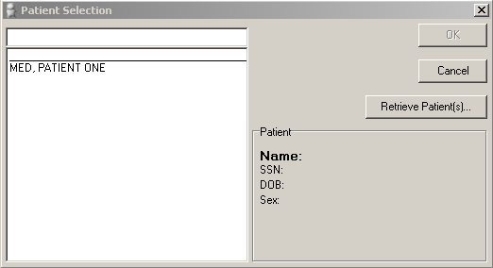

REF: For more information on selecting patient records in MED, see Section 4, "Selecting a Patient," in this manual.

NOTE: While connected to the VA network/VistA, if you do not supply the appropriate signon credentials you can access MED but cannot retrieve patients and summaries. You must sign into MED using the appropriate signon credentials before being given access to retrieve patient information from VistA.

REF: If you encounter any errors when running MED, see "Appendix B—Troubleshooting" for more information.

This page intentionally left blank for double-sided printing.

Retrieving Patient Records

Retrieving Patient Records Overview

Patient lists should be retrieved (not just selected) within Mobile Electronic Documentation (MED) on a regular basis in order to ensure updated Health Summaries for all the patients the clinician might visit (including unscheduled visits).
- Retrieving Patient Records — When you retrieve patient records in MED, you are obtaining updated patient data (e.g., Health Summaries) from Veterans Information Systems Technology Architecture (VistA) and updating the MED Microsoft® Access database. In order to retrieve patient records in MED, you must be connected to VistA and will be prompted to enter your VistA signon credentials.
- Selecting Patient Records -When you select patient records in MED, you are selecting previously retrieved patients from the MED Microsoft® Access database. In order to select patient records in MED, you do not need to be connected to VistA and will not be prompted to enter your VistA signon credentials.

REF: For more information on selecting patient records in MED, see Section 4, "Selecting a Patient," in this manual.

You can refresh patient information from Veterans Information Systems Technology Architecture (VistA) if you are connected to the Department of Veterans Affairs (VA) Network and have been assigned the Mobile Electronic Documentation secondary option [TIU MED GUI RPC]. This ensures that recent updates will be reflected. For example:
- Patient Information (e.g., Name, SSN, DOB)
- Health Summary

CAUTION: If the patient name on the list is not a manually entered patient, when MED is started, any notes that have been imported over 7 days prior are deleted. Then, any patients that are over 7 days old and do not have any pending or imported notes are deleted as well.

NOTE: Patient retrieval time is only affected if over 20 patients are retrieved at one time.

Retrieving Patient Records Procedures

To retrieve patient records, perform the following procedures:

NOTE: While connected to the VA network/VistA, if you do not supply the appropriate signon credentials (i.e., PIV PIN /VA Access and Verify codes) you can access MED but cannot retrieve patients and summaries. You must sign into MED using the appropriate signon credentials before being given access to retrieve patient information from VistA.

- Choose either of the following options to retrieve patient records:
- On the Patient Selection dialogue (Figure 2), click the Retrieve Patient(s) button.
- On the MED menu toolbar:
- Select the File menu.
- Select Retrieve Patient(s) menu option.

The following Retrieve Patient(s) dialogue opens:

Figure 3. MED—Retrieve Patient(s) dialogue
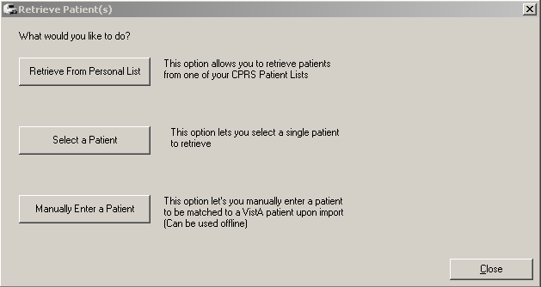

- From the Retrieve Patient(s) dialogue (Figure 3), you have three choices to retrieve patients:
- Retrieve From Personal List—Retrieve from a CPRS Personal List. It is recommended that you create a Personal List in CPRS and keep it updated.
- Click the Retrieve From Personal List button.
- Sign onto VistA: Enter your PIV PIN or Access/Verify code.

NOTE: If you are not prompted for your signon credentials, contact IRM to verify that the correct IP address and port number have been assigned to the MED shortcut executable target line. If further assistance is needed, please enter a National Remedy ticket or call the National Service Desk-Tuscaloosa at 1-888-596-4357 for assistance.
- Select one of your personal lists in the left pane under "Personal List."
- Check/Uncheck the patient(s) you want to download to MED in the middle pane under "Patients."
- Click the Retrieve Checked Patients button in the right pane.

Figure 4. MED—Retrieve Patient(s): Personal Lists dialogue
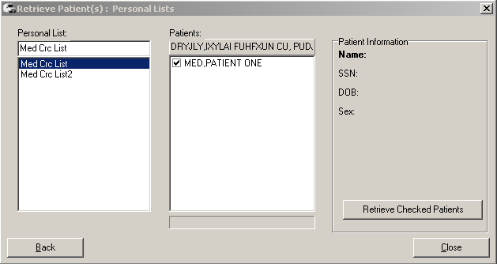

- Select a Patient—Retrieve a single patient.
- Click the Select a Patient button to retrieve a single patient.
- Sign onto VistA: Enter your PIV PIN or Access and Verify codes.

NOTE: If you are not prompted for your signon credentials, contact IRM to verify that the correct IP address and port number have been assigned to the MED shortcut executable target line. If further assistance is needed, please enter a National Remedy ticket or call the National Service Desk-Tuscaloosa at 1-888-596-4357 for assistance.
- Select a patient from the displayed list in the left pane, as you would in CPRS.
- Click the Retrieve Patient button in the right pane.

Figure 5. MED—Retrieve Patient(s): Select Patient dialogue
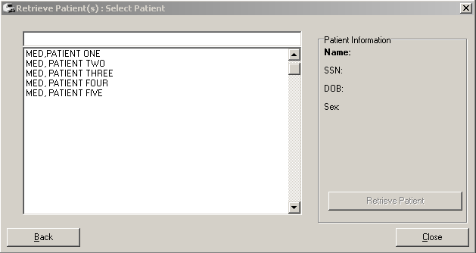

- Manually Enter a Patient

NOTE: Manual entry is for adding a patient in the event you did not download the patient prior to leaving the facility, or there is an unscheduled visit.

REF: For important information about importing notes for manually entered patients, see the "Importing MED Notes into CPRS" section.
- Click the Manually Enter a Patient button.
- Enter the Name in the following format as you would in VistA:
LAST NAME,FIRST NAME,MIDDLE INITIAL

NOTE: If the user types Last Name,First Name with a space after the comma, the patient will not be recognized when attempting to import into CPRS.
- Enter the nine-digit Social Security Number (SSN).
- Enter the Date of Birth (DOB) by doing either of the following:
- To easily and quickly add the DOB, manually enter the month, day, and year as follows:
- Single click on the value you want to change.
- Enter the desired number.
- Repeat for all DOB values as needed.
- Select the date from the dropdown list. You will have to scroll through the calendar dates to arrive at the correct year, since the MED DOB year defaults to 1899.
- Click the Save Patient button.

Figure 6. MED—Retrieve Patient(s): Manually enter a Patient dialogue
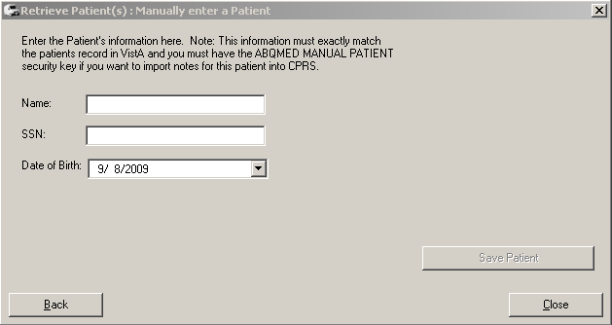

The updated information will be stored in the local database and new or updated patients will be available at the "Patient Selection" screen.

NOTE: Health Summaries are stored as .hsm files in the db folder of MED. This folder resides on the local laptop that is used for the Home Based Primary Care (HBPC) visits.
- Press the Close button once you have selected all of your patients from VistA in order to exit out of VistA and return to MED.

Delete Manually Entered Patients (Duplicates)

A duplicate patient record in the MED database (i.e., identical Last Name, First Name, SSN, and DOB) may occur when a provider manually enters a patient into MED while in the field, because he/she does not see that the VistA patient has already been retrieved into the MED patient list (i.e., MED Access database). If the provider enters a note to the VistA retrieved patient record and not the manually entered record, it will not get imported.

When importing a note for a duplicate patient, the MED import process first finds the manually entered patient. Since the note was not added to the manually entered patient, MED does not find a note for that patient. The only way to import the note for that patient is to delete the manually entered patient from the MED Access database.

Manually entered patients will never be automatically deleted. These patients can only be deleted from the patient list through the database. To delete a manually added patient from the MED Access database/selection list contact your CAC or IRM for assistance.

Selecting a Patient

After starting the Mobile Electronic Documentation (MED) software, the Patient Selection dialogue appears, as shown below:

Figure 7. MED—Patient Selection dialogue

NOTE: In order to select patient records in MED, you do not need to be connected to VistA and will not be prompted to enter your VistA signon credentials.

Select a patient record to view. If you have a list of patients from which to select, perform the follow procedures:
- On the MED Patient Selection dialogue, select the patient using one of the following methods:
- Choose a patient from the displayed list of patient names.
- Type the first letter of the patient's last name and the last four digits of the patient's Social Security Number (SSN) (e.g., M0001).
MED will try to match what you entered to a patient and highlight that patient. The patient's name and other information will appear below in the Patient Box located below the Retrieve Patient(s) button.
- Verify that the correct patient is highlighted.
- If the correct patient is highlighted, click OK.
- If the correct patient is not highlighted:
- Scroll through the list to find the correct patient.
- Highlight the name.
- Click OK.

NOTE: If MED finds more than one patient with the same last name and same last four digits of the SSN, the possible matches will be shown above the dividing line. Select the correct patient and click OK.
- When you click OK, MED opens to the Summary Tab (see Section 7).

If you do not have a list of patients to select from, you will need to click on the "Retrieve Patient(s)" button. The process of retrieving patients is described in the previous section.

Patient Information Available from Any Tab

Patient Information for the currently selected patient is located at the top of the MED window and is available from any tab. The patient information includes:
- Name
- Social Security Number (SSN)
- Date of Birth (DOB)

Figure 8. MED—Patient information

This page intentionally left blank for double-sided printing.

Printing from Within MED

Printing Health Summaries and Notes Overview

MED allows you to print the following information for patients:
- Reports: Patients with Notes Report—Report showing the patients that have Notes and Pending/Imported Notes for the Current Patient
- Health Summaries
- Individual Patient Notes
- Scratch Pad entries

Use the instructions in the topics that follow to print MED reports to network Microsoft Windows printer.

Printing Health Summaries and Notes Procedures

To print Health Summaries, Scratch Pad entries, Reports, and multiple Notes in MED, perform the following procedures:
- Launch MED.
- Select a patient to make the MED menu options visible on the Patient Selection form (see Section 4).
- Select the File menu.
- Select the Print option, as shown below:

Figure 9. MED Menus—File and Print options (partial capture)
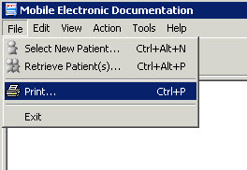

- The MED Print Documents dialogue opens, as shown below:

Figure 10. MED—Print Documents dialogue: Sample list of notes that can be printed
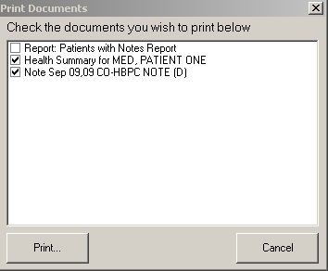

- Select the documents you want to print by checking the checkbox next to each item. The Health Summary, Scratch Pad entries, and the currently selected Note (if applicable) are checked by default.
- Click Print. The Print dialogue opens, as shown below:

Figure 11. MED—Print dialogue
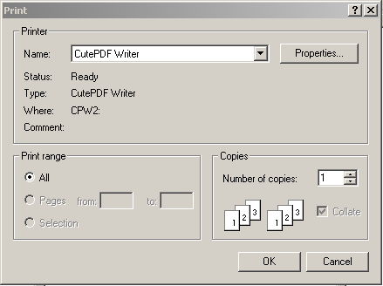

- Select the Printer to which the documents should be sent and click OK.

Summary Tab

Summary Tab Overview

The Summary Tab is the first dialogue screen you see after selecting a patient. This tab displays the Health Summary text-based overview of a patient's condition and history, which includes:
- Patient demographics
- Advance Directive information
- Active problems
- Allergies and postings
- Active medications
- Clinical reminders
- Lab results
- Vitals
- List of appointments or visits

The actual information available depends on the Health Summary selected in the MED parameters. The local Clinical Application Coordinator (CAC) can modify the Health Summary displayed in MED as desired by the site.

Figure 12. MED—Health Summary tab dialogue
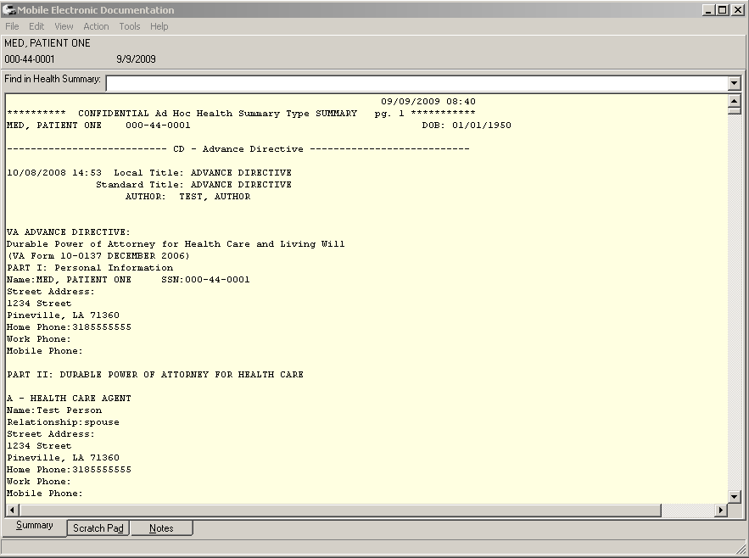

The MED Health Summary displays a variety of information about a patient.

Summary Tab Procedures

You can type or select an item in the Find in Health Summary list to quickly jump to a section within the Health Summary. Health Summaries are retrieved by default.

CAUTION: The effect of disabling retrieval of Health Summaries results in no Health Summaries being displayed for all patients.

Retrieve Health Summaries from VistA

To change if Health Summaries are retrieved from VistA, perform the following procedures:
- Launch MED:
- Select a patient to make the MED menu options visible on the Patient Selection form (see Section 4).
- Select the Tools menu.
- Select the Settings option, as shown below:

Figure 13. MED Menus—Tools and Settings options (partial capture)
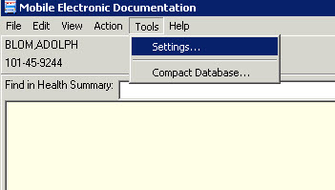

- The Users & Settings dialogue opens. If not already selected, click on the Data & Files tab, as shown below:

Figure 14. MED Users & Settings dialogue—Data & Files
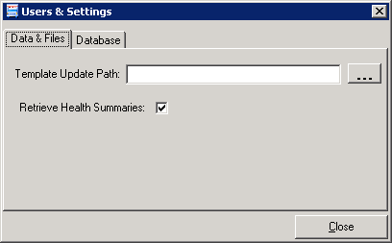

- Check/Uncheck the Retrieve Health Summaries checkbox option.

CAUTION: Unchecking the Retrieve Health Summaries checkbox disables retrieving/displaying Health Summaries results for all patients.

Find Health Summary Text

To find specific text in the Health Summary, perform the following procedures:
- Click Health Summary text.
- Select Edit\Find. The Find dialogue opens, as shown below:

Figure 15. MED—Find dialogue
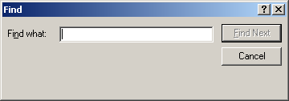

- Enter the text that you want to find.
- Click Find Next. If the text is found, it will be highlighted in the Health Summary.

Figure 16. MED—Health Summary tab: Find dialogue
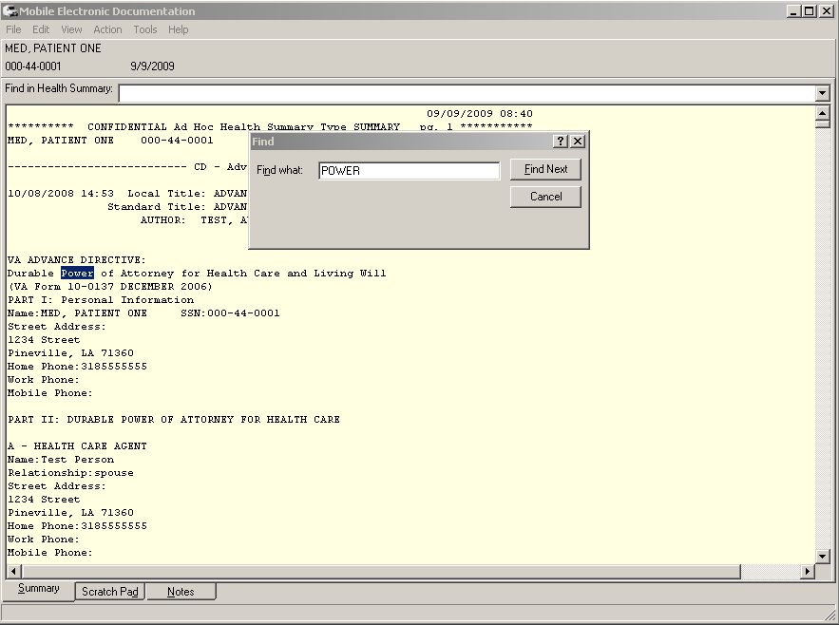

Create and Assign a Health Summary to MED

The Home Based Primary Care (HBPC) staff should develop a Health Summary that is suitable for the type of care that they will be providing to their patients. Only one Health Summary can be assigned to a user. The CAC is responsible for creating and assigning the HBPC Health Summaries that will be used:
- Review the current Health Summaries in CPRS:
- Select the Reports tab.
- Select Health Summary.
- Create a robust vs. minimal Health Summary to be used with MED; however, the MED Health Summary does not replace the need to review a patient's record in CPRS in preparation for patient visits. The length of the summary does not affect the length of time it takes to retrieve patients.

NOTE: Patient retrieval time is only affected if over 20 patients are retrieved at one time.

Scratch Pad Tab

Scratch Pad Tab Overview

The Scratch Pad allows you to store notes and other information for referral. This information can be viewed and/or printed, but cannot be copied or imported into the Computerized Patient Record System (CPRS). The purpose for Scratch Pad is similar to a post-it note. The local Clinical Application Coordinator (CAC) can create templates for you to use in the Scratch Pad if desired by the site (see Section 8.3).

Figure 17. MED—Scratch Pad tab dialogue
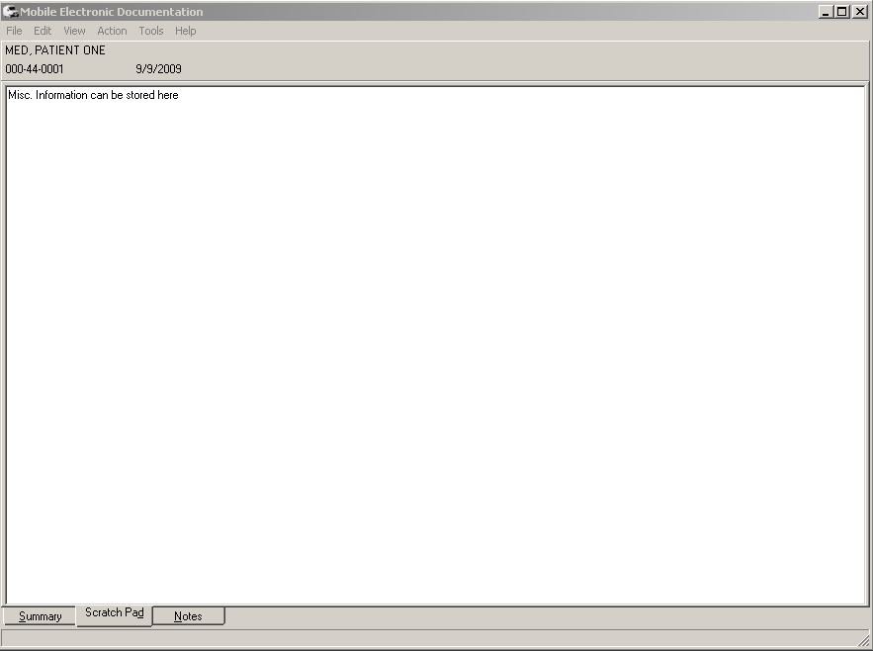

Scratch Pad Procedures

Write Scratch Pad Text

To write text in the Scratch Pad, perform the following procedures:
- Launch Mobile Electronic Documentation (MED).
- Click on the Scratch Pad tab.
- Enter any text in the white text box below the patient's Name, SSN, and DOB, as shown below:

Find Scratch Pad Text

To find specific text in the Scratch Pad, perform the following procedures:
- Click the Scratch Pad tab.
- Select Edit\Find. The Find dialogue opens, as shown below:

Figure 18. MED—Find dialogue

- Enter the text that you want to find.
- Click Find Next. If the text is found, it will be highlighted in the Scratch Pad.

Figure 19. MED—Scratch Pad tab: Find dialogue
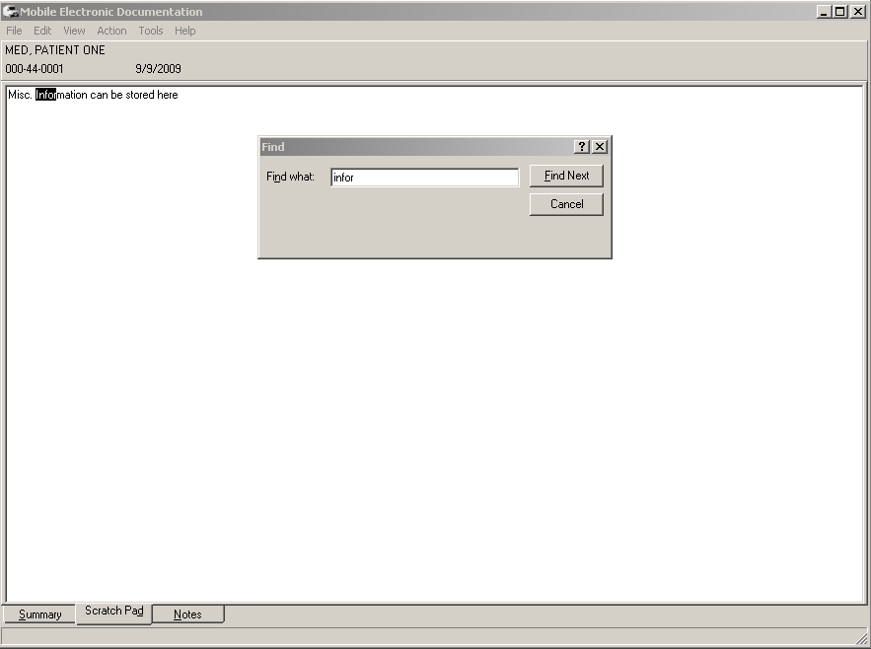

Delete Scratch Pad Text

To delete text in the Scratch Pad, perform the following procedures:
- Highlight the text portion you want to delete.
- Right-click on the selected text.
- Press Delete.

Creating Templates and Directory Access

A user can create a "personal template" in Text Integration Utility (TIU) if your site has enabled the CPRS parameter to perform this task. If you have a "personal template" that you would like to use in MED, contact your CAC or IRM to assist you.

REF: For information on how to create Personal Templates, please refer to the TIU User Manual.

The local site Clinical Application Coordinator (CAC) can create TIU templates (.txml format). The CAC then exports those templates, with the exception of Reminder Dialogs, through the CPRS Template Editor into the Templates folder on the network share directory for use with MED Scratch Pad. MED only recognizes template files with the .txml extension.

NOTE: Reminder Dialogs cannot be used within the MED application. In addition, you can use patient data objects in any template, but the data will not populate until the template is imported into CPRS.

By creating a network location to store MED templates, template management can be maintained on the network server instead of each individual laptop/client workstation. Those templates will automatically be pulled from the shared network directory to the local laptop/client workstation Templates folder when the user launches MED:
C:/Program Files/Mobile Electronic Documentation/Templates

REF: For more information on Network Share Templates directory, see the "Create a Network Share Download Directory" section in the Mobile Electronic Documentation (MED) Technical Manual.

Deleting Templates

The local Clinical Application Coordinator (CAC) or IRM staff can delete templates for you.

REF: For more information on deleting templates, see the "Deleting Templates" section in the Mobile Electronic Documentation (MED) Technical Manual.

Notes Tab

From the Notes tab you can create a new Mobile Electronic Documentation (MED) note for a patient and view existing Pending and Imported Notes. Documents on the Notes tab are organized in a directory tree structure on the left side of the screen.

Icons on the Notes Tab

The icons in front of the document titles on the Notes tab help identify and categorize documents. For example:
- Notes Pending Import into Computerized Patient Record System (CPRS).
- Notes Imported into CPRS within the Past 7 Days.

Viewing Notes

To view the text of a Note, perform the following procedures:
- Click the Notes tab.
- Select a document title from the "Notes for this Patient" section in the upper left pane of the screen. The text of the Note will be displayed on the right pane of the screen.

Figure 20. MED—Notes tab
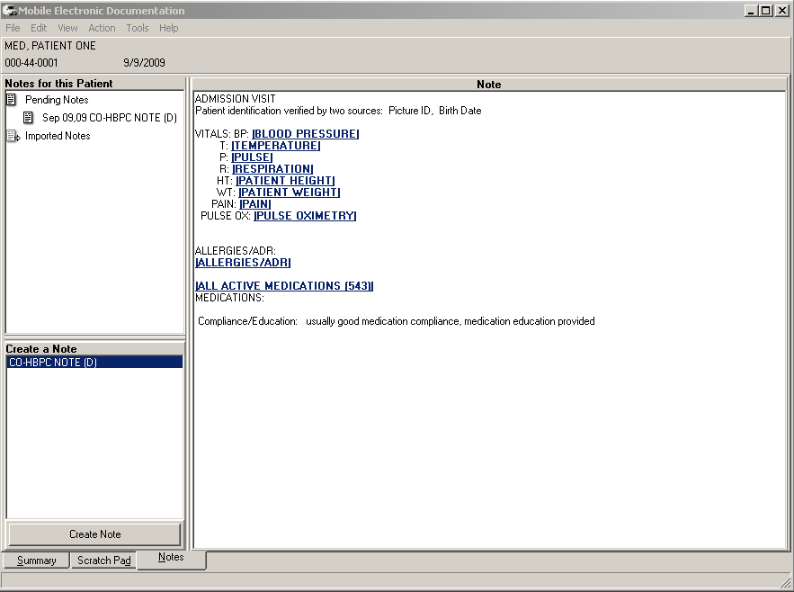

Creating and Editing Notes

To create a new Note, perform the following procedures:
- Click the Notes tab.
- Select the type of note to create from the "Create a Note" section in the lower left pane of the screen.

Figure 21. MED—Create a Note dialogue: Sample list of note templates that can be created
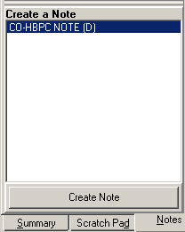

- Click the Create Note button. The Template screen for the type of Note you selected appears.
- Fill in the information as you do in CPRS, and then click OK.

NOTE: Patient Data objects cannot be edited or deleted. The information for that object will be updated by MED when you import the note into CPRS.

Figure 22. MED—Home Based Primary Care (HBPC) template: CO-HBPC Note (D)
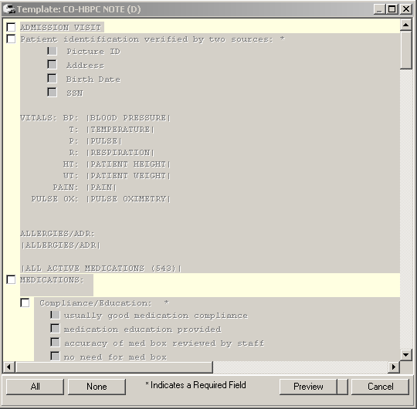

Editing Existing Notes

To edit an existing Note, perform the following procedures:
- Click the Notes tab.
- Select a document from the left upper pane of the screen labeled "Notes for this patient". The text of the Note will be displayed on the right side of the screen labeled "Note".
- Select Action\Edit Note. You can now edit the Note.

NOTE: Patient Data objects cannot be edited or deleted.

Saving Notes

Currently, the MED software does not provide a Save button or auto-save action on the Notes tab. As a workaround, to save a note and write the data to the MED database on the laptop/client workstation, do one of the following actions:
- Close the MED software using the Close button ("X"), as shown below:

Figure 23. MED—Close button
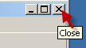

- Select a new patient (see Section 4).

CAUTION: Do not shut down the laptop/client workstation before properly closing MED; otherwise, data may be lost!
Simply pressing the OK button does not save the note. In order to save your note, you must close MED by pressing the Close button ("X"; see Figure 23) to exit out of MED prior to closing, shutting down, or putting your laptop on standby. If you do not close MED first, the last note you created will not be saved to the MED database.

Finding Text in Notes

To find specific text in a Note, perform the following procedures:
- Click the Notes tab.
- Select a document from the left upper pane of the screen labeled "Notes for this patient". The text of the note will be displayed on the right side of the screen labeled "Note".
- Right-click the text of the note.
- Select Find. The Find dialogue opens, as shown below:

Figure 24. MED—Find dialogue

- Enter the text that you want to find.
- Click Find Next. If the text is found, it is highlighted in the Note.

Figure 25. MED—Notes tab: Find dialogue
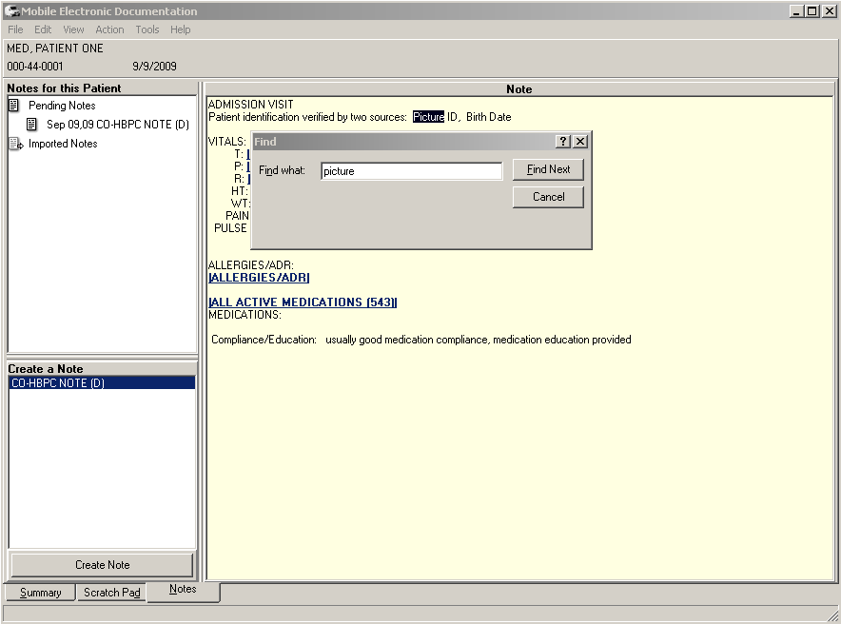

This page intentionally left blank for double-sided printing.

Importing MED Notes into CPRS

From the Notes tab in the Computerized Patient Record System (CRPS) application you can import Notes from the Mobile Electronic Documentation (MED) application. You must be connected to the Department of Veterans Affairs (VA) network to import notes from MED into CRPS.

Existing Progress Notes

To import a MED Note into an existing CPRS Progress Note for a patient, perform the following procedures:
- Launch CPRS and select the patient whose notes you wish to import.

Figure 26. CPRS—Patient Selection dialogue
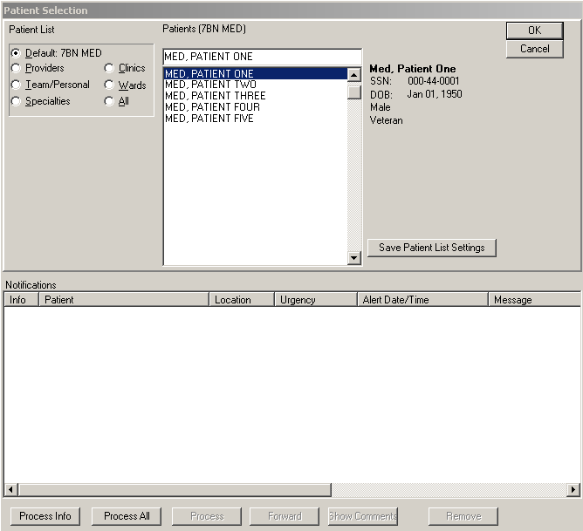

- Select the Notes tab of CPRS.
- Create or Edit a note, and move the cursor to where you would like to import the MED Note.
- Double-click Templates\Shared Templates\Mobile Electronic Documentation. The Select Note to Import dialogue will open, as shown below:

Figure 27. CPRS—Select Note to Import dialogue
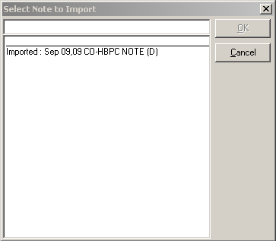

- Select the note to import.
- Click OK.
- The note will be imported into the CPRS Note that is currently being edited.

NOTE: Patient data objects embedded in the note will be retrieved from VistA and updated with the appropriate values at the time of the import.

New Progress Notes

To create a new MED Progress Note and import it for a patient into CPRS, perform the following procedures:
- Launch CPRS and select the Patient whose notes you wish to import.

Figure 28. CPRS—Patient Selection dialogue

- Select the Notes tab of CPRS.
- Ensure that you are not editing an existing note.
- Double-click: Templates\Shared Templates\Mobile Electronic Documentation\Import M.E.D. Notes.
- Select the location (if prompted), and enter the Progress Note properties.

Figure 29. CPRS—Progress Note Properties dialogue
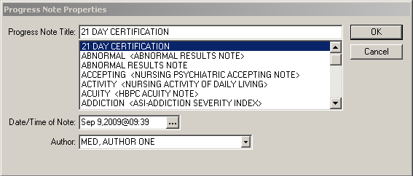

- If there is a template associated with the Progress Note Title, complete it as usual. The "Select Note to Import" dialogue opens, as shown below:

Figure 30. MED—Select Note to Import dialogue (sample 1 of 2)
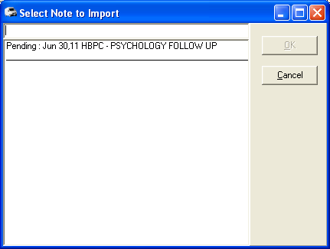

Figure 31. MED—Select Note to Import dialogue (sample 2 of 2)
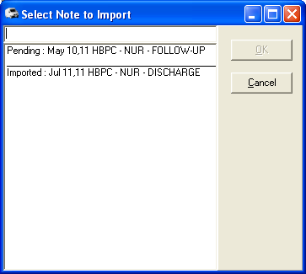

- Select the note to import.
- Click OK.
- The note will be imported into the newly created CPRS Note.

NOTE: An MED Import Note can be associated with a CPRS Progress Note title allowing you to create and import a note as you do in CPRS.

Import Criteria for Progress Notes

Date Sensitivity

It is important to note that when MED is started it checks progress note dates and does the following:
- If the patient name on the list is not a manually entered patient, when MED is started, any notes that have been imported over 7 days prior are deleted.
- Any patients that are currently on the user's patient list over 7 days old and that do not have any pending or imported notes are deleted as well.
- Manually entered patients will never be automatically deleted. These patients can only be deleted from the patient list through the database.

IMPORTANT: In order to avoid deletion of any progress notes or patient lists from MED and to get the latest Health Summary information, users should retrieve their patient lists every day!

Security Keys

If you have a progress note for a manually entered patient, you must hold one of the following MED security keys:

Table 1. MED—Security keys for validating patient identification for manually entered MED patients
Security Key | Description
TIU MED MANUAL PATIENT | If you hold this security key, the following must match exactly:  - The first letter of the last name.  - The first letter of the first name.  NOTE: If the user types Last Name,First Name with a space after the comma, the patient will not be recognized when attempting to import into CPRS.  - The date of birth (DOB).  - The nine-digit Social Security Number (SSN).
TIU MED MANUAL OVERRIDE | If you hold this security key, the full SSN must match exactly.  CAUTION: Most users must not be given the TIU MED MANUAL OVERRIDE security key.  It is suggested that there be a document review and patient review before importing notes into patient records that have typographical or missing data that stops a user from importing the information as outlined with the TIU MED MANUAL PATIENT security key.

Import Examples

For example, if you hold the TIU MED MANUAL PATIENT security key and have added a manually entered patient like the one shown below, you will be allowed to import.

Table 2. Import Example—TIU MED MANUAL PATIENT security key
CPRS Patient:  Name: MED,PATIENT ONE  DOB: 01/01/1950  SSN: 000-44-0001 | MED Patient:  Name: MED,PATIENTS ONE  DOB: 01/01/1950  SSN: 000-44-0001

However, if you have added a manually entered patient like any of those shown below, you will not be allowed to import if you only have the TIU MED MANUAL PATIENT security key.

Holders of the TIU MED MANUAL OVERRIDE security key can import patients with different names:

Table 3. Import Example—TIU MED MANUAL OVERRIDE security key: Different names
CPRS Patient:  Name: MED,PATIENT ONE  DOB: 01/01/1950  SSN: 000-44-0001 | MED Patient:  Name: MED,CASE ONE  DOB: 01/01/1950  SSN: 000-44-0001

Holders of the TIU MED MANUAL OVERRIDE key can import patients with different DOBs:

Table 4. Import Example—TIU MED MANUAL OVERRIDE security key: Different DOB
CPRS Patient:  Name: MED,PATIENT ONE  DOB: 01/01/1950  SSN: 000-44-0001 | MED Patient:  Name: MED,PATIENT ONE  DOB: 01/21/1950  SSN: 000-44-0001

This record cannot be imported regardless of the security key a user holds, since the SSN does not match:

Table 5. Import Example—Unable to import due to different SSNs
CPRS Patient:  Name: MED,PATIENT ONE  DOB: 01/01/1950  SSN: 000-44-0001 | MED Patient:  Name: MED,PATIENT ONE  DOB: 01/01/1950  SSN: 000-44-0002

Appendix A—Keyboard Shortcuts for Common MED Commands

This appendix discusses the keyboard shortcut equivalents for common Mobile Electronic Documentation (MED) commands. This allows users who prefer using shortcuts or other users with limited vision or dexterity to use the software effectively and make it accessible.

Navigation Commands

Table 6. MED Navigation commands—Keyboard shortcuts
MED Navigation Command | Keyboard Shortcut
Select the Health Summary tab | Ctrl + S
Select the Notes tab | Ctrl + N
Advance to the next field, button, or control (left to right) | Tab
To exit a field that accepts tabs (e.g., the text of a Note) and move to the next control (left to right) | Control + Tab
To exit a field that accepts tabs and move to the previous control (right to left) | Shift + Control + Tab
Pull down a list box | Down Arrow
Navigate a list box | Up Arrow or Down Arrow
Select an item in a list box | Enter
To switch between the tabbed page of a dialogue box | Control + Tab
To toggle a check box on or off | Spacebar

File Menu Commands

Table 7. MED File menu commands—Keyboard shortcuts
File Menu Command | Keyboard Shortcut
Select New Patient | Alt-F-N or Ctrl + Alt + N
Retrieve Patient List | Alt-F-L or Ctrl + Alt + P
Print | Alt-F-P or Ctrl + P
Exit | Alt-F-X

Edit Menu Commands

Table 8. MED Edit menu commands—Keyboard shortcuts
Edit Menu Command | Keyboard Shortcut
Undo | Alt-E-U or Ctrl + Z
Find | Alt-E-F or Ctrl + F
Cut | Alt-E-T or Ctrl + X
Copy | Alt-E-C or Ctrl + C
Paste | Alt-E-P or Ctrl + V
Select All | Alt-E-A or Ctrl + A

View Menu Commands

Table 9. MED View menu commands—Keyboard shortcuts
View Menu Command | Keyboard Shortcut
Summary Tab | Alt-V-S or Ctrl + S
Notes Tab | Alt-V-N or Ctrl + N

Tools Menu Commands

Table 10. MED Tools menu commands—Keyboard shortcuts
Tools Menu Command | Keyboard Shortcut
Change Password | Alt-T-P
Users & Settings | Alt-T-U
Compact Database | Alt-T-C

Action Menu Commands

Table 11. MED Action menu commands—Keyboard shortcuts
Action Menu Command | Keyboard Shortcut
Delete Note | Alt-A-D
Edit Note | Alt-A-E

Help Menu Commands

Table 12. MED Help menu commands—Keyboard shortcuts
Help Menu Command | Keyboard Shortcut
Contents | Alt-H-C
About MED | Alt-H-A

This page intentionally left blank for double-sided printing.

Appendix B—Troubleshooting

This appendix discusses the various errors and other messages you may encounter while using the Mobile Electronic Documentation (MED) application.

NOTE: If the resolutions listed for the errors described in this section do not resolve the error or problem, please enter a National Remedy ticket or call the National Service Desk-Tuscaloosa at 1-888-596-4357 for assistance.

Patch TIU*1*257 is Not Current in VistA Error

Error Message:

The following error may be displayed when an older version of MED is installed or is the wrong KIDS version in VistA:

Figure 32. MED Error—Patch TIU*1*257 is not current in VistA
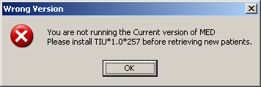

Description:

MED is not installed or an older version is installed on VistA.

Resolution:

Install/Reinstall Patch TIU*1.0*257 (TIU*1.0*257.KID package).

MED Missing Remote Procedure Calls (RPCs) in VistA Error

Error Message:

The following error may be displayed when an older version of MED is installed in VistA:

Figure 33. MED Error—Missing RPCs
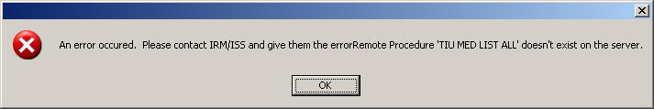

Description:

MED is not installed or an older version is installed on VistA and is missing remote procedure calls (RPCs).

Resolution:

Install/Reinstall Patch TIU*1.0*257 (TIU*1.0*257.KID package).

Invalid Pointer Operation Error

Error Message:

The following error may be displayed if the MED VistA KIDS install is not correct:

Figure 34. MED Error—Invalid pointer operation
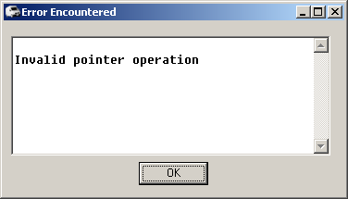

Description:

The MED application is missing all the remote procedure calls (RPCs).

Resolution:

Install/Reinstall Patch TIU*1.0*257 (TIU*1.0*257.KID package).

Application Context Error

Error Message:

The following error may be displayed for MED application context errors:

Figure 35. MED Error—Application context
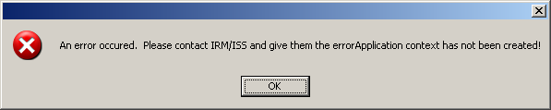

Description:

Application context is a menu requirement for using all Remote Procedure Call (RPC) Broker calls. Each application has its own application context. The MED application context is TIU MED GUI RPC V2.

Resolution:

The TIU MED GUI RPC V2 menu option is distributed with Patch TIU*1*257 and needs to be assigned to all MED users, either on a common menu or one of the user's secondary menus.

Write Access Error

Error Message:

The following access error may be displayed for MED application users who do not have the appropriate access permissions to the MED directory:

Figure 36. MED Error—Write access permissions error
Exception EFCreateError in module MED.exe at 0002363E
Cannot create file "C:\Program Files\Mobile Electronic Documentation\med.err". Access is denied.

Description:

The user does not have the appropriate access permissions to the MED executable directory on the client workstation/laptop. In order for users to write the appropriate information while using the MED software, all users must be given Full Control access permission to the following MED application directory:
C:\Program Files\Mobile Electronic Documentation

Resolution:

Give all users Full Control access permission to the following MED application directory on the client workstation/laptop:
C:\Program Files\Mobile Electronic Documentation

CPRS CHART – Library Not Registered Error

Error Message:

The following access error may be displayed when trying to import a MED note into CPRS for those MED application users who do not have the appropriate access permissions to the MED directory:

Figure 37. MED Error—CPRS CHART – Library Not Registered Error
CPRS CHART – Library Not Registered

Description:

The user does not have the appropriate access permissions to the MED executable directory on the client workstation/laptop. In order for users to write the appropriate information while using the MED software, all users must be given Full Control access permission to the following MED application directory:
C:\Program Files\Mobile Electronic Documentation

Resolution:

Give all Home Based Primary Care (HBPC) users Full Control access permission to the following MED application directory on the client workstation/laptop:
C:\Program Files\Mobile Electronic Documentation

MED Database Open Error

Error Message:

The following error may be displayed if there is a problem with opening the MED database:

Figure 38. MED Error—Database is not installed correctly
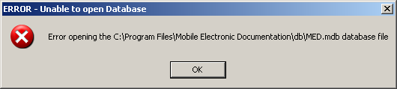

Description:

The MED.mdb database should be in the following db subdirectory:
C:\Program Files\Mobile Electronic Documentation\db\MED.mdb

Resolution:

Install/Reinstall Patch TIU*1.0*257 (TIU*1.0*257.KID package).

MED Database Compact Messages

Warning Message:

The following warning message will be displayed when compacting the MED Microsoft® Access database:

Figure 39. MED Warning—Database closing
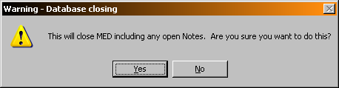

After clicking YES, you should see the following message:

Figure 40. MED Information Message—Database Compacted
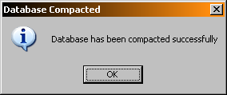

After pressing OK, MED closes.

Description:

When the MED database meets or exceeds this size in the Suggest Compact After (MB) field (default value is 1024 MB), MED automatically prompts the user to compact the database. Currently, it is suggested the user answer No to compact the database when prompted. If users choose to compact the database they will see a series of warning and action messages (see above).

The MED.mdb database should be in the following db subdirectory:
C:\Program Files\Mobile Electronic Documentation \db\MED.mdb

REF: For more information on compacting the MED database, see Step 3o in the "Configure Client Workstation" section in the Mobile Electronic Documentation (MED) Technical Manual.

Resolution:

Close and save all open notes before compacting the MED Microsoft® Access database.

Network Connection Error

Error Message:

The following blank dialogues may be displayed if the MED RPC Broker fails to make a VistA connection:

Figure 41. MED Error—Network Connection: Blank Retrieve Patient(s) dialogue (1 of 2)
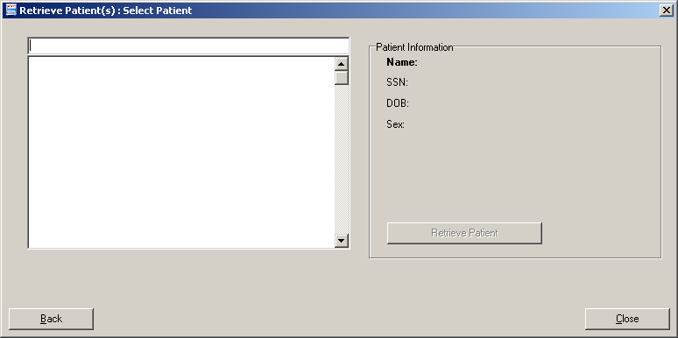

Or:

Figure 42. MED Error—Network Connection: Blank Retrieve Patient(s) dialogue (2 of 2)
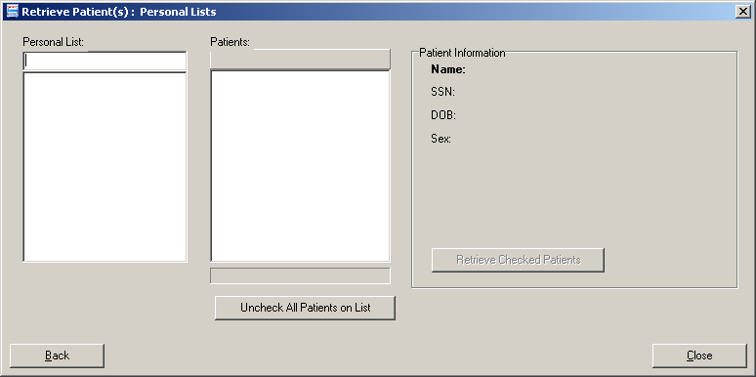

Description:

There may be a very long pause after selecting Retrieve Patients, and then the Retrieve Patients dialogue is blank. MED is running but not connected to VistA.

Resolution:

Check the desktop shortcut. Verify that the IP server address and port number is correct. Also, check for a network connection error.

RPC Broker Error

Error Message

You may see the following Remote Procedure Call (RPC) Broker error dialogue when starting MED:

Figure 43. Errors—RPC Broker Error: Patient list retrieval error
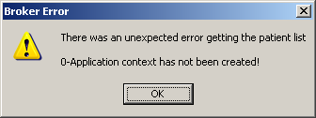

Description:

This means that the user has not been assigned the Mobile Electronic Documentation secondary option [TIU MED GUI RPC].

Resolution:

Contact the Information Resource Management (IRM) or Clinical Applications Coordinator (CAC) to gain access to the Mobile Electronic Documentation secondary option [TIU MED GUI RPC V2].

CPRS Error

Error Message

You may see the following dialogue when trying to import notes into CPRS:

Figure 44. Errors—CPRS - Patient Chart Error: Importing notes error message
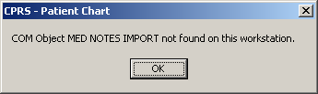

Description:

You may be trying to import MED notes on a computer that does not have MED installed. For example, MED is installed on the laptop/client workstation, but you are trying to import MED notes on another client workstation.

Resolution:

If MED is loaded on the laptop/client workstation, contact IRM for assistance to "re-register" the MEDImport.dll file and then restart CPRS.

Invalid Date Error

Error Message:

The following error may be displayed during the patient import process:

Figure 45. MED Error—Invalid date
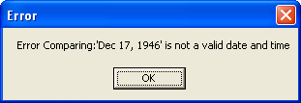

Description:

The Date of Birth (DOB) is in the wrong format in the MED database (MED.mdb). Click the OK button to retrieve more details.

Resolution:

Verify that the correct MED GUI Version 2.3.311.6 is running on the laptop/client workstation. If it is the correct GUI, then the current patient information is from a prior version. To fix this, use the current MED GUI to retrieve the patient data and it will properly update the DOB in the MED database.

Missing Required Data Fields Error

Error Message:

The following types of error messages may be displayed for missing data fields (highlighted):

Figure 46. MED Error—Missing required data fields and Section 508 compliance: Active Caption Color
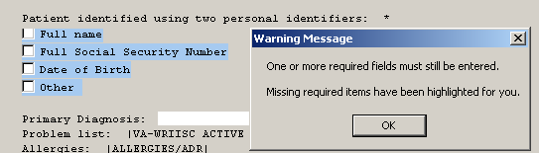

Description:

Required fields in templates that are missing data will display a warning message, and the missing fields will be highlighted in blue. Just as in CPRS, the template cannot be completed and saved unless the required fields are completed. Unlike CPRS regular dialog templates, the missing fields will be obviously marked.

NOTE: Prior versions of MED highlighted required missing data fields in yellow. To make MED Section 508 compliant, the color of the fields is now set to Active Caption Color.
REF: For more information on making templates Section 508 compliant, see the "Missing Required Data Fields Error" section in this manual.

Resolution:

Enter the missing required data fields.

Users can reset he highlight colors by changing the Microsoft® Windows theme.

This page intentionally left blank for double-sided printing.

Appendix C—Mobile Electronic Documentation (MED) Frequently Asked Questions (FAQ)

# | Question | Answer
1 | Will I need to purchase a certain device or hardware in order to use Mobile Electronic Documentation (MED)? | No. MED can run on any Microsoft® Windows-based laptop/client workstation, but is not designed for use with a tablet device.
2 | How can I get MED, and is it only available for the Home Based Primary Care (HBPC) Programs? | MED is a standalone application. All VA facility Information Technology (IT) departments have the software, which is installed on individual laptops/client workstations. MED is not restricted for use in the HBPC program. The software can be used by any VA staff needing access to the patient electronic medical records when not connected to the VA network.
3 | Can I still use other programs such as CPRS, Microsoft (MS) Outlook or VistA when I am using MED. | Yes. You can use MED with other programs that IT has installed on the laptop/client workstation. MED actually requires interaction with VistA and CPRS for loading the patient information and transferring the notes into the clinical record.
4 | Can I use MED at home? | Yes, if you have virtual private network (VPN) access. MED can be used with VPN in the office or at home. You can upload and download patient progress notes in MED while using VPN.
5 | What must I do prior to having the MED software loaded on my laptop? | To prepare for using MED, you will need a customized Health Summary. You will need a list of progress note templates that will be used with MED. The Clinical Application Coordinator will assist you to design customized health summaries and progress note templates that you will use in MED.
6 | Do I need any special permission or security clearance in order to use the MED software? | No. The MED software meets all VA security and encryption requirements.
7 | How much time does it take to retrieve (download) a list of patients in MED? | For small lists of 20-30 patients, it takes approximately 3-5 minutes. Larger lists containing over 150 patients will take approximately 30-35 minutes to download into MED.
8 | Will MED alert the user to restricted patient records? | Yes. MED will start the retrieval process which includes restricted record. MED will display them at the end the retrieval process, alerting the user in the same manner that CPRS does. The user then has the option to continue to retrieve the restricted record or not to.
9 | Can I complete clinical reminders when using MED? | No. As an option, you can complete a clinical reminder by editing a MED progress note once the template is uploaded into CPRS, prior to signature (completing the note).
10 | Why can't I cut and paste from the scratch pad?  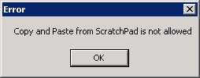 | This is to ensure that users do not accidentally copy and paste into the wrong patient record. You can copy and paste into the scratch pad, but you cannot copy and paste from the scratch pad.
11 | Will the ePads for obtaining consents and signatures on Advanced Directives be compatible with the MED program? | MED is not designed for use with iMed Consent. MED is only compatible with CPRS.
12 | Will MED do appointing and scheduling? | No, MED doesn't link with either the Appointment Management or Event Capture modules.
13 | Can you enter Encounter information while working in MED? | The encounter will need to be created and completed in CPRS when transferring the notes from MED.
14 | What do I need to do to safeguard patient information in MED since it doesn't have its own password? | The patient information is protected on the laptop/client workstation using several key steps Virtual Private Network (VPN) security, encryption and protection while communicating with the VA servers (CPRS, VistA, Outlook, etc.), Microsoft® Windows-based password protection and User physical safeguard of the computer while signed on such as ensuring information not viewable or available to unauthorized users.

Glossary

CPRS | Computerized Patient Record System, the VistA package (in both GUI and character-based formats) that provides access to most components of the patient chart.
CAC | Clinical Applications Coordinator. The CAC is a person at a hospital or clinic assigned to coordinate the installation, maintenance and upgrading of CPRS and other VistA software programs for the end users.
HEALTH SUMMARY | A VistA product that can be viewed through CPRS, Health Summaries are components of patient information extracted from other VistA applications.
HBPC | Home Based Primary Care.
PROGRESS NOTES | A component of TIU that can function as part of CPRS.
VISTA | Veterans Information Systems Technology Architecture.
MED | Mobile Electronic Documentation. Application that provides remote documentation and importing of notes into CPRS.
MED NOTES | Notes created from exported CPRS Templates that can then be re-imported into CPRS.
RETRIEVING PATIENT RECORDS | When you retrieve patient records in MED, you are obtaining updated patient data (e.g., Health Summaries) from Veterans Information Systems Technology Architecture (VistA) and updating the MED Microsoft® Access database. In order to retrieve patient records in MED, you must be connected to VistA and will be prompted to enter your VistA signon credentials (i.e., Access and Verify codes).
SELECTING PATIENT RECORDS | When you select patient records in MED, you are selecting previously retrieved patients from the MED Microsoft® Access database. In order to select patient records in MED, you do not need to be connected to VistA and will not be prompted to enter your VistA signon credentials.

This page intentionally left blank for double-sided printing.

Index

A
Access Error, 50
CPRS CHART – Library Not Registered Error, 50
Accessibility, 43
Action Menu Commands, 44
Adobe Website, xxii
Appendix A—Keyboard Shortcuts for Common MED Commands, 43
Appendix B—Troubleshooting, 47
Appendix C—Mobile Electronic Documentation (MED) Frequently Asked Questions (FAQ), 59
Application Context Error, 49
Assumptions about the Reader, xxi
C
Callout Boxes, xix
Commands
Action Menu, 44
Edit Menu, 44
File Menu, 43
Help Menu, 45
Keyboard Shortcuts, 43
Navigation, 43
Tools Menu, 44
View Menu, 44
Common MED Commands
Keyboard Shortcuts, 43
Contents, xi
CPRS, 37
Importing Notes, 35
CPRS CHART – Library Not Registered Error, 50
CPRS Error, 55
Create a Note, 29
Creating Notes, 29
D
Database, 10
MED Database Compact Messages, 52
MED Database Open Error, 51
Dates
Progress Notes, 39
Desktop Shortcut, 3
Disclaimers, xviii
Document Title, 28
Documentation Conventions, xix
Documentation Navigation, xx
E
Edit Existing Notes, 31
Edit Menu Commands, 44
Editing Notes, 29
Errors, 47
Application Context, 49
CPRS, 55
CPRS CHART – Library Not Registered Error, 50
Invalid Date, 56
Invalid Pointer Operation, 48
MED Database Open, 51
MED Missing Remote Procedure Calls (RPCs) in VistA, 48
Missing Required Data Fields, 56
Network Connection, 53
Patch TIU*1*257 is Not Current in VistA, 47
RPC Broker, 54
Section 508, 57
Write Access, 50
Existing Progress Notes, 35
F
Figures, xv
File Menu Commands, 43
Finding Text in Notes, 32
Frequently Asked Questions (FAQ), 59
G
Glossary, 61
GUI
Online Help, xxi
H
Health Summary, 5, 15, 16, 17, 18, 21, 59
Find, 19, 20
Tab
Overview, 17
Procedures, 19
Find Text, 20
Retrieve, 19
Help
Online, xxi
Help Menu Commands, 45
History, Revisions to Documentation and Patches, iii
Home Pages
Adobe Website, xxii
VHA Software Document Library (VDL)
Website, xxii
VistA Development Website, xviii
How to
Obtain Technical Information Online, xx
Use this Manual, xvii
I
Icons on the Notes Tab, 27
Import Criteria for Progress Notes, 39
Importing
MED Notes into CPRS, 35
Intended Audience, xviii
Introduction, 1
Invalid Date Error, 56
Invalid Pointer Operation Error, 48
K
Keyboard Shortcuts
Common MED Commands, 43
L
Launching MED, 3
Legal Requirements, xviii
Library Not Registered Error
CPRS CHART, 50
M
MED
Desktop Shortcut, 3
Introduction, 1
Notes Tab, 27
Printing, 15
Progress Notes Date Sensitivity, 39
Retrieving Patient Records, 5
Scratch Pad Tab, 23
Selecting a Patient, 11
Starting, 3
Tabs
Summary, 17
MED Database Compact Messages, 52
MED Database Open Error, 51
MED Missing Remote Procedure Calls (RPCs) in VistA Error, 48
Missing Required Data Fields Error, 56
Mobile Electronic Documentation option, 5, 55
N
Navigation Commands, 43
Network Connection Error, 53
New Progress Notes, 37
Notes, 44
Creating, 29
Edit Existing, 31
Editing, 29
Finding Text, 32
Icons, 27
Importing, 35
Viewing, 28
Notes Tab, 27
O
Obtaining
Data Dictionary Listings, xxi
Technical Information Online, How to, xx
Online
Help, xxi
Options
Mobile Electronic Documentation option, 5, 55
TIU MED GUI RPC, 5, 55
TIU MED GUI RPC V2, 55
Orientation, xvii
Overview
Health Summary
Tab, 17
Printing Health Summaries and Notes, 15
Retrieving Patient Records, 5
Scratch Pad Tab, 23
P
Patch TIU*1*257 is Not Current in VistA Error, 47
Patient Information Available from Any Tab, 13
Patient Records
Retrieving, 5
Patient Selection, 6, 10
Patients
Selecting, 11
Permissions Error, 50
CPRS CHART – Library Not Registered, 50
Printing
Within MED, 15
Printing Health Summaries and Notes
Overview, 15
Procedures, 15
Procedures
Health Summary
Tab, 19
Find Text, 20
Retrieve, 19
Printing Health Summaries and Notes, 15
Retrieving Patient Records, 6
Scratch Pad Tab, 23
Delete Text, 25
Find Text, 24
Write Text, 23
Progress Note, 38
Progress Notes
Existing, 35
Import Criteria, 39
Importing into CPRS, 35
New, 37
PS Anonymous Directories, xxii
R
Reader, Assumptions about the, xxi
Reference Materials, xxi
Requirements
Legal, xviii
Retrieve Patient(s), 6
Retrieving Patient Records, 5
Overview, 5
Procedures, 6
Revision History, iii
RPC Broker Error, 54
S
Scratch Pad Tab, 23
Overview, 23
Procedures, 23
Delete Text, 25
Find Text, 24
Write Text, 23
Security Keys, 40
TIU MED MANUAL OVERRIDE, 40
TIU MED MANUAL PATIENT, 40
Selecting a Patient, 11
Starting MED, 3
Summary
Tab, 17
T
Table of Contents, xi
Tables, xvi
Tabs
Notes, 27
Patient Information Available from Any Tab, 13
Scratch Pad, 23
Summary, 17
Template, 29, 38
TIU MED GUI RPC Option, 5, 55
TIU MED GUI RPC V2 Option, 55
TIU MED MANUAL OVERRIDE Security Key, 40
TIU MED MANUAL PATIENT Security Key, 40
Tools Menu Commands, 44
Troubleshooting, 47
U
URLs
Adobe Website, xxii
VHA Software Document Library (VDL)
Website, xxii
VistA Development
Website, xviii
V
VHA Software Document Library (VDL)
Website, xxii
View Menu Commands, 44
Viewing Notes, 28
W
Warnings
MED Database Compact, 52
Web Pages
Adobe Website, xxii
VHA Software Document Library (VDL)
Website, xxii
VistA Development Website, xviii
Write Access Error, 50

